How AI/ML is implemented in Data science
--From ChatGPT
Data Science ⊃ Artificial Intelligence ⊃ Machine Learning
Data Science is the umbrella field — it’s about extracting meaningful insights and value from data using statistical, computational, and business methods.
AI refers to building systems that can mimic human intelligence — perception, reasoning, learning, decision-making.
ML is a subset of AI that learns patterns from data to make predictions or decisions automatically.
So, AI/ML are implemented within Data Science workflows to automate analysis, uncover patterns, and make intelligent predictions.
2. Typical Data Science Workflow (with AI/ML steps)
Step | Description | AI/ML Role
1. Data Collection | Gather raw data from databases, APIs, sensors, social media, etc. | —
2. Data Cleaning & Preparation | Handle missing values, normalize data, feature engineering. | —
3. Exploratory Data Analysis (EDA) | Use statistics & visualization to understand data patterns. | —
4. Model Building (ML stage) | Apply machine learning algorithms (supervised/unsupervised) to train predictive models. | ✅ ML core
5. Model Evaluation | Assess model accuracy using metrics (accuracy, F1, RMSE, etc.). | ✅ ML evaluation
6. AI Integration | Use trained models to build intelligent systems — chatbots, recommender systems, fraud detection, etc. | ✅ AI application
7. Deployment & Monitoring | Put model into production; monitor drift and retrain periodically. | ✅ Continuous AI/ML learning

3. How AI/ML Are Implemented in Practice
a. Machine Learning Algorithms
Used to find relationships or make predictions from data:
- Supervised learning: Regression, Decision Trees, Random Forest, SVM, Neural Networks (predict known labels)
- Unsupervised learning: Clustering (K-Means), Dimensionality Reduction (PCA)
- Reinforcement learning: Used for decision-making and control systems
b. Deep Learning (Advanced ML)
For large, unstructured data such as images, audio, or text:
- CNNs → image recognition
- RNNs/LSTMs → time series & NLP
- Transformers → modern AI language models (like GPT 😊)
c. AI Applications built from ML models
Examples:
- Recommendation systems (Netflix, Amazon)
- Predictive maintenance (manufacturing)
- Customer churn prediction (telecom, SaaS)
- Fraud detection (finance)
- Natural language processing (chatbots, sentiment analysis)
- Computer vision (self-driving cars, healthcare imaging)

4. Tech Stack Commonly Used
Layer | Tools / Frameworks
Data Handling | Python, R, SQL, pandas, NumPy
Data Visualization | Matplotlib, Seaborn, Power BI, Tableau
Machine Learning | scikit-learn, XGBoost, LightGBM
Deep Learning / AI | TensorFlow, PyTorch, Keras
Data Pipelines | Apache Spark, Airflow, MLflow
Deployment | Docker, Flask/FastAPI, AWS SageMaker, Azure ML, GCP Vertex AI

5. Example: Predicting Customer Churn (AI/ML in Data Science)
- Collect customer usage data → (Data Science)
- Clean & transform → (Data Engineering)
- Train ML model (e.g., XGBoost) to predict churn probability → (ML)
- Deploy model to auto-flag at-risk customers → (AI system)
- Generate retention strategies → (Applied Data Science Insight)
So AI/ML transforms static analysis into actionable intelligence.

6. Why AI/ML Are Crucial in Data Science
Benefit | Impact
Automation of pattern detection | Saves manual analysis time
Predictive insights | Enables data-driven forecasting
Real-time decisioning | Powers AI-driven systems
Continuous learning | Models improve automatically as new data arrives
Scalability | Handles massive datasets beyond human capacity

Exploratory Data Analysis
Statistical Modelling
Sample mean: Mean of a subset of Total Data Set
Population Mean: Mean of Total Data Set
Variance
Reference :
Variance - Clearly Explained (How To Calculate Variance)
https://www.youtube.com/watch?v=x0rmUXWtSS8
Variance: average of the squared differences from the mean(mean referred here is Population Mean)
Population variance = $\frac{{(x-µ)}^{2}}{n}$ and Sample variance= $\frac{{(x-ẍ)}^{2}}{n-1}$
n-1 in sample variance is called as Bessel’s Correction
Eg: Weight of the Dogs
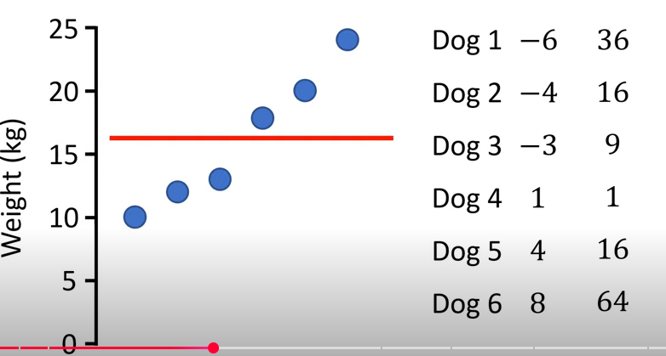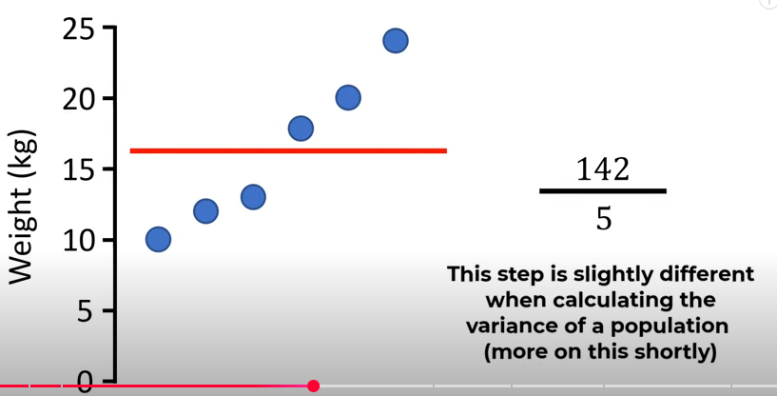
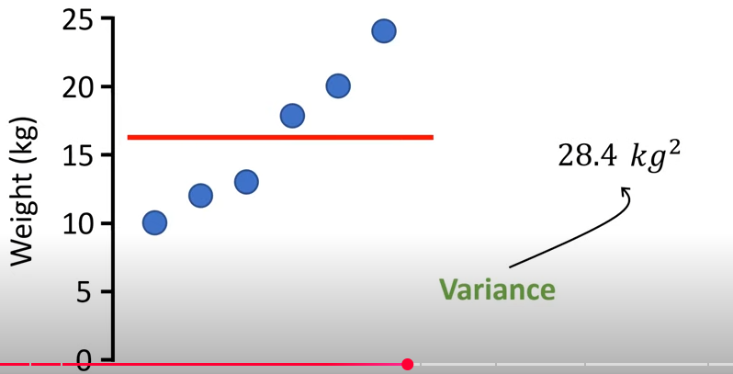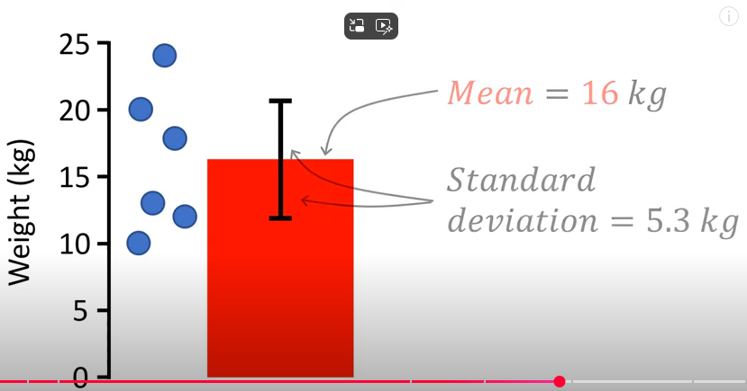

Variance and Standard Deviation: Why divide by n-1?
Reference : Variance and Standard Deviation: Why divide by n-1?
https://www.youtube.com/watch?v=wpY9o_OyxoQ
Variance Objective: to describe the spread of the data from the mean

why the variance is in squared Units?
Negative deviation will nullify the positive Deviation when we are trying to find out the average deviation from the mean
Hence, squaring all the deviations and then finding out the average deviation, but now the units are in Squared Units. i.e. scale of the variance is not inline with the scale of the data points. Hence taking square root which will now be termed as Standard Deviation
If negative deviations nullify the positive counterpart, why can’t we go for considering the absolute values (instead of squaring them) and averaging them?
As a Convention process, we don’t do that.
Another good reason is, square of these deviations from the mean forms the part of a larger study of statistics called moments. i.e. squaring of the deviations from the mean form the second order moment in statistics
Cubing of the deviations from the mean form the third order moment in statistics
Power of 4 of the deviations from the mean form the Fourth order moment in statistics

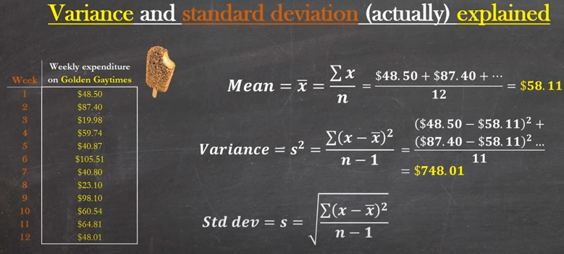
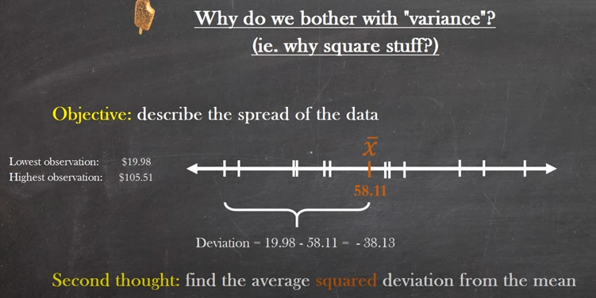
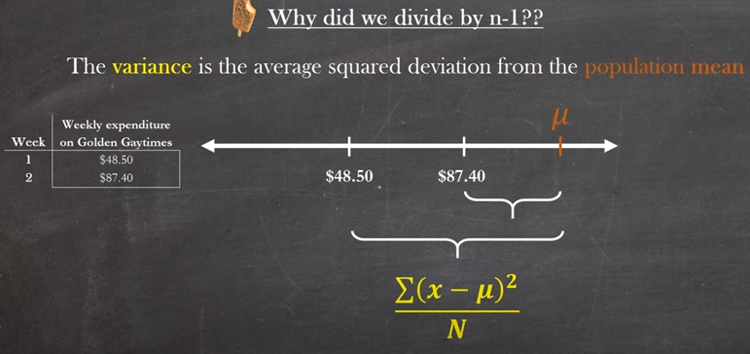
For a subset of data, i.e a set of samples, if population mean is considered for calculation, square of deviations from the mean will be much higher and hence the estimated variance of the samples will be higher which is not the actual case to be.
For that, we are using the estimate of the population mean which we call it as sample mean $ẍ$.

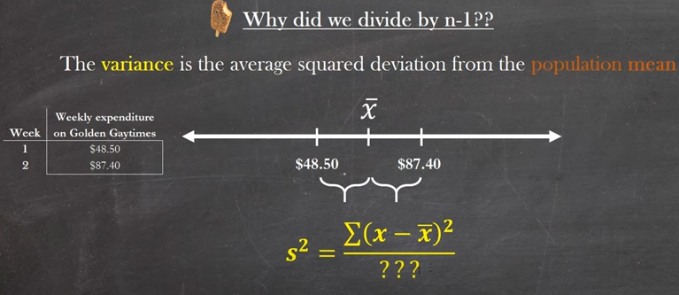
Note: $ẍ$ is an estimate of the population mean. i.e. sample mean is always an estimate of the population mean.in other words, sample mean is one POSSIBLE position for the true population mean.
Elephant in the Room: Degrees of Freedom… ha ha
Consider below the population mean and estimate of the population mean which is nothing but Sample mean.
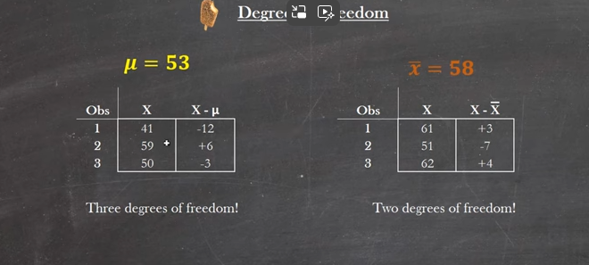

$sum(x-µ)$ doesn’t need to be Zero as shown above
But, sum($x-ẍ$) must be equal to Zero as $ẍ$ is given to us.
For calculating the deviation from the population mean, the data point can be whatever from the data set. And there is no constraint that sum of deviations equal to zero.
But for calculating the deviation from the sample mean(since this will be explicitly given to us), sum of deviation should always be equal to zero.
So, From the above image eg. Since $ẍ=58$, the first two data points can be anything(Two degrees of Freedom) and so their deviations, but the third data point should be in such a way that it’s deviation when added with other two deviations should equals to zero. So, the Third data point must be 62 here.
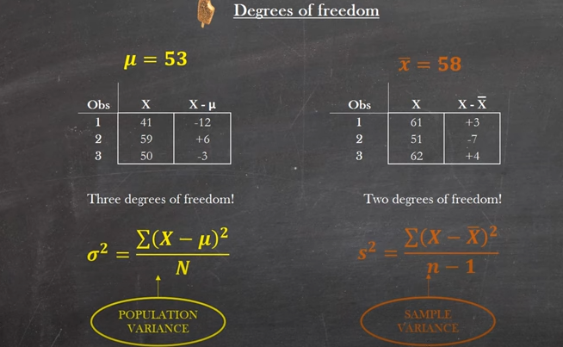
Population Variance:(${(-12)}^{2}+6^{2}+{(-3)}^{2})/12$ => 94.5 SD= 9.72
Whereas, Sample variance: (${(3)}^{2}+{(-7)}^{2}+{(4)}^{2})/(3-1)$=> 37 SD= 6.08

Degree of freedom:
Ref :https://www.youtube.com/watch?v=rATNoxKg1yA
Number of Independent pieces of information needed to compute the Statistical measure like mean, variance and SD.
But Degrees of Freedom<>N
If one piece of Information is known through the Outcome, Then Another Information can be easily identified. It implies One Degree of Freedom
Eg :
- Coin Tose, if head occurs, then other will be a Tail
- If same coin is tossed 100 times and 60 occurrences are head, even then we can conclude that remaining 40 are tails
Two degrees of Freedom:
Eg: Among Red, Green and Yellow, what will be the colour of next light in the Traffic?
To answer this, we need to know the previous two lights to Ans the correct one
It implies, two pieces of information required to find the possible outcome.
So, For N pieces, N-1 pieces are required to find the possible outcome.
N-1 is referred as Degree of Freedom.
In other words, if you know the mean, the last input value is no longer an Unpredictable one.
What is Degrees Of Freedom in Statistics? Degrees of freedom in Statistics Explained!
https://www.youtube.com/watch?v=uaM5cgU2WKs
“… Number of Independent ways in which a dynamic system can move, without violating any constraint imposed on it..”
Number of Observations in the data that are free to vary when we attempt to estimate statistical parameters

In estimating the sample mean, we have already lost one degree of freedom.
If we are Replacing the Population mean $µ$ with the Estimated mean/Sample Mean $ẍ$
and the sample mean being fixed and if we are estimating the SD,
SD of Population Mean, σ = $\sqrt{\frac{{(x-µ)}^{2}}{n}}$ => Estimate of SD of Population Mean, S = $\sqrt{\frac{{(x-ẍ)}^{2}}{n-1}}$

Population by Name implies the complete dataset. If any data points changes, the entire statistical parameters mean, and SD need to be reworked. thereby we are not using any degree of freedom.
Degrees of Freedom works in the same way when
- Estimating Regression Parameters
- Chi Square Tests
- Skewness
- kurtosis
And it depends on what is being estimated

Coefficient of Variation
CV= Standard Deviation/ Sample Mean i.e. CV= $\frac{σ}{ẍ}$
Unlike Standard deviation which is inline to the scale of the actual data points, CV will be in proportionate Terms.
In other words, SD will be in absolute terms whereas CV will be in Proportionate Terms
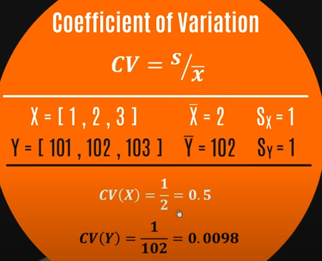
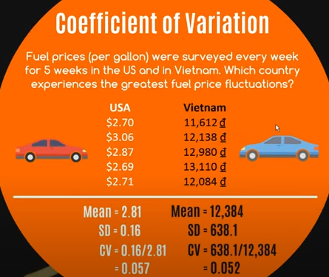
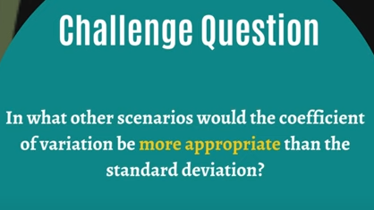
Ans: CV is more appropriate when we want to compare between two different datasets (different units) which has less or more spread. Whereas standard deviation is helpful us to compare the spread similar types of data sets (same unit).
COV is useful in cases where we have different units for comparison like weights in pound and kg.

Derivatives:
Introduction to Derivatives
https://www.mathsisfun.com/calculus/derivatives-introduction.html
You do differentiation ... to get a derivative.
A derivative basically gives you the
slope of a function at any point.

Gradient Descent
Moving Average
Trend Component
Seasonal Component
Seasonality Index

https://onlinecourses.nptel.ac.in/noc25_cs46/preview

Week 0: Probability Theory, Linear Algebra, Convex Optimization - (Recap)
Week 1: Introduction: Statistical Decision Theory - Regression, Classification, Bias Variance
Week 2: Linear Regression, Multivariate Regression, Subset Selection, Shrinkage Methods, Principal Component Regression, Partial Least squares
Week 3: Linear Classification, Logistic Regression, Linear Discriminant Analysis
Week 4: Perceptron, Support Vector Machines
Week 5: Neural Networks - Introduction, Early Models, Perceptron Learning, Backpropagation, Initialization, Training & Validation, Parameter Estimation - MLE, MAP, Bayesian Estimation
Week 6: Decision Trees, Regression Trees, Stopping Criterion & Pruning loss functions, Categorical Attributes, Multiway Splits, Missing Values, Decision Trees - Instability Evaluation Measures
Week 7: Bootstrapping & Cross Validation, Class Evaluation Measures, ROC curve, MDL, Ensemble Methods - Bagging, Committee Machines and Stacking, Boosting
Week 8: Gradient Boosting, Random Forests, Multi-class Classification, Naive Bayes, Bayesian Networks
Week 9: Undirected Graphical Models, HMM, Variable Elimination, Belief Propagation
Week 10: Partitional Clustering, Hierarchical Clustering, Birch Algorithm, CURE Algorithm, Density-based Clustering
Week 11: Gaussian Mixture Models, Expectation Maximization
Week 12: Learning Theory, Introduction to Reinforcement Learning, Optional videos (RL framework, TD learning, Solution Methods, Applications)

Linear Algebra - GeeksforGeeks
https://www.geeksforgeeks.org/maths/linear-algebra/

What is Linear Algebra?
Linear Algebra is a branch of Mathematics that deals with matrices, vectors, finite and infinite spaces. It is the study of vector spaces, linear equations, linear functions, and matrices.
Linear Algebra Equations
The general linear equation is represented as u1x1 + u2x2+.....unxn= v
Where,
- u’s – represents the coefficients
- x’s – represents the unknowns
- v – represents the constant
There is a collection of equations called a System of linear algebraic equations. It obeys the linear function such as -
(x1,……..xn) → u1x1+……….+unxn

Linear Algebra Topics
Below is the list of important topics in Linear Algebra.
- Matrix inverses and determinants
- Linear transformations
- Singular value decomposition
- Orthogonal matrices
- Mathematical operations with matrices (i.e. addition, multiplication)
- Projections
- Solving systems of equations with matrices
- Eigenvalues and eigenvectors
- Euclidean vector spaces
- Positive-definite matrices
- Linear dependence and independence
- The foundational concepts essential for understanding linear algebra, detailed here, include:
- Linear Functions
- Vector spaces
- Matrix
Generally, vectors are entities that can be combined, and linear functions refer to vector operations that encompass vector combination.
Branches of Linear Algebra
Linear Algebra is divided into different branches based on the difficulty level of topics, which are,
- Elementary Linear Algebra
- Advanced Linear Algebra
- Applied Linear Algebra

Elementary Linear Algebra

Elementary Linear algebra covers the topics of basic linear algebra such as Scalars and Vectors, Matrix and matrix operation, etc.

Linear Equations
Linear equations form the basis of linear algebra and are equations of the first order. These equations represent straight lines in geometry and are characterized by constants and variables without exponents or products of variables. Solving systems of linear equations involves finding the values of the variables that satisfy all equations simultaneously.
A linear equation is the simplest form of equation in algebra, representing a straight line when plotted on a graph.

Example: 2x + 3x = 6 is a linear equation. If you have two such equations, like 2x + 3y = 6, and 4x + 6y =12, solving them together would give you the point where the two lines intersect.

Advanced Linear Algebra

Advanced linear algebra mostly covers all the advanced topics related to linear algebra such as Linear function, Linear transformation, Eigenvectors, and Eigenvalues, etc.

Eigenvalues and Eigenvectors
Eigenvalues and eigenvectors are fundamental concepts in linear algebra. It offers deep insights into the properties of linear transformations. An eigenvector of a square matrix is a non-zero vector that, when the matrix multiplies it, results in a scalar multiple of itself. This scalar is known as the eigenvalue associated with the eigenvector. They are essential in various applications, including stability analysis, quantum mechanics, and the study of dynamical systems.

Consider a transformation that changes the direction or length of vectors, except for some special vectors that only get stretched or shrunk. These special vectors are eigenvectors, and the factor by which they are stretched or shrunk is the eigenvalue.

Example: For the matrix A = [2, 0, 0, 3], the vector v = 1,0 is an eigenvector because Av = 2v, and 2 is the eigenvalue.

Detail
Eigenvalues and eigenvectors are fundamental concepts in linear algebra, used in various applications such as matrix diagonalization, stability analysis and data analysis (e.g., PCA). They are associated with a square matrix and provide insights into its properties.
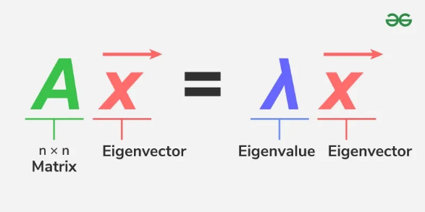
Eigenvalues
Eigenvalues are unique scalar values linked to a matrix or linear transformation. They indicate how much an eigenvector gets stretched or compressed during the transformation. The eigenvector's direction remains unchanged unless the eigenvalue is negative, in which case the direction is simply reversed.

Applications of Eigen Values and Eigen
Some of the common applications of eigen values are:
Google PageRank Algorithm
- Web pages form a graph; eigenvector corresponding to eigenvalue 1 of the link matrix gives each page’s importance score.
Markov Processes & Steady-State Analysis
- Used in simulations, natural language processing, recommendation systems, and stochastic modeling.
- The eigenvector for eigenvalue 1 gives long-term stable probabilities.
Principal Component Analysis (PCA)
- Reduces dimensionality of data, removes noise, and extracts key patterns.
- Common in image recognition, machine learning, and data compression.
Latent Semantic Analysis (LSA) in NLP
- Eigen-decomposition (via SVD) finds semantic relationships between words and documents.
- Improves search, document clustering, and recommendation engines.
Spectral Graph Theory in Network Analysis
- Eigenvalues of the graph Laplacian help detect communities, find graph partitions, and measure connectivity in social networks or computer networks.
Computer Vision (Eigenfaces)
- Eigenvectors from face image datasets form a “basis” for recognizing and comparing faces.
Control System Stability in Robotics & AI
- Eigenvalues of system matrices determine stability and convergence of autonomous systems and learning algorithms.
Signal Processing & Data Transmission
- Eigen-decomposition optimizes communication channels, feature extraction in audio/speech, and noise filtering.

Purpose of Eigenvalues and Eigenvectors : (Ref : Chat GPT)
- Understanding Linear Transformations:
  - When you generally apply a matrix (which represents a linear transformation) to a vector, the vector usually changes direction and length.
  - Eigenvectors are special vectors that only get stretched or shrunk by the transformation, but their direction remains the same.
  - The factor by which an eigenvector is stretched or shrunk is the corresponding eigenvalue.

- Simplifying Complex Problems:
  - Eigenvalues and eigenvectors help to diagonalize matrices, making complex matrix operations easier.
  - This simplification is crucial for solving systems of linear equations, differential equations, and performing matrix exponentiation.
- Applications:
Physics: Understanding stability, vibrations, and quantum states.
Data Science / Machine Learning: Principal Component Analysis (PCA) uses eigenvectors and eigenvalues to reduce the dimensionality of data by finding directions (principal components) with the most variance.
Engineering: Modal analysis to study natural frequencies of structures.
Computer Graphics: Rotation and scaling transformations.

Intuitive example:
If you think of a matrix as a transformation that squashes, stretches, or rotates space, eigenvectors are the directions that don’t change direction after this transformation, and eigenvalues tell you how much those directions are stretched or compressed.

Would you like me to show an example of how eigenvectors are used in a practical application?

What is PCA?
PCA finds the principal directions (eigenvectors) along which your data varies the most, and the eigenvalues tell you the amount of variance captured along those directions. This helps to reduce the number of features while keeping most of the information.

Real-Time Implementation Example: Face Recognition (Simplified)
In face recognition systems, PCA is used to reduce the dimensionality of face images, extracting the most important features (called eigenfaces).

What happens here? (Paste it under the Pytho Code)
- We load face images and flatten them.
- Compute the covariance matrix of centered data.
- Find eigenvalues and eigenvectors of the covariance matrix.
- The eigenvectors with largest eigenvalues correspond to the directions (features) where data varies the most.
- These top eigenvectors are called eigenfaces and can be used to reconstruct or recognize faces with reduced dimensionality.

https://byjus.com/maths/eigenvector/
Almost all vectors change their direction when they are multiplied by A. Some rare vectors say x is in the same direction as Ax. These are the “eigenvectors”. Multiply an eigenvector by A, and the vector Ax is the number time of the original x. The basic equation is given by:
Ax = λx.
Here, the number λ is an eigenvalue of matrix A.
Frequently Asked Questions – FAQs
Q1
What are eigenvectors used for?
Eigenvalues and eigenvectors are used to reduce a linear operation to separate or simplify the problems.
Q2
How do you find eigenvectors?
The below steps help in finding the eigenvectors of a matrix.
Step 1: Find the eigenvalues of the given matrix A, using the equation det ((A – λI) =0, where “I” is an identity matrix of equivalent order as A.
Step 2: Denote each eigenvalue of λ_1, λ_2, λ_3,…
Step 3: Substitute the values in the equation AX = λ1 or (A – λ1 I) X = 0.
Step 4: Calculate the value of eigenvector X, which is associated with the eigenvalue.
Step 5: Repeat the steps to find the eigenvector for the remaining eigenvalues.
Q3
What do eigenvalues and eigenvectors tell us?
An eigenvalue is a number that tells us how much variance exists in the data in that direction, whereas an eigenvalue is a number that tells us how spread of the data.
Q4
Are eigenvectors orthogonal?
Generally, for any matrix, the eigenvectors are not always orthogonal. However, they will be orthogonal for a particular type of matrix such as a symmetric matrix.
Q5
Are all eigenvectors linearly independent?
Eigenvectors are linearly independent when the corresponding eigenvalues of a matrix are distinct.
For Visualization
Eigenvalue-Eigenvector Visualization – GeoGebra
https://www.geogebra.org/m/JP2XZpzV

What do eigenvalues and eigenvectors represent intuitively? What is their significance? - Quora

Murtuza Shareef
Studied at The University of Texas at Arlington11y
Originally Answered: What is the best way to intuitively explain what eigenvectors and eigenvalues are?
Assuming you know how to calculate the eigen values and eigen vectors of a give matrix. I will try to explain the intuition behind
the eigen vectors.
For example you have a matrix of data points in n-dimensional space where n is say very high value. (Try to imagine a scatter of points bunched together with no correlation between them). So your data points or your observations are highly dimensional. When that is the case, it is imperative that, there will be some kind of noise in your data. If you want to reduce this noise, you may want to project your data into a new space which minimizes the noise.
This space is called the eigen space and the vectors or the axes of this space are called eigen vectors and what determines the length of the axes are the eigen values.
So, when you project your original matrix onto this space, the data points from your original matrix tends to get attached/aligned with the axes of this space. Thereby, reducing the noise and giving you the principal components in your data that are orthogonally separated.
Let us take a layman langauge. Consider people living a city and you would want to know who among those people like jazz pop rock indie etc. Imagine the people in this city as the data points. Imagine you are a very rich person and you like to spend money. One fine day you get an idea of calling in popular musicians who are best at those mentioned kinds of music. Once they come to your town you announce it to the people and you conduct these music events at places separated by large distances in 4 different quadrants and guess what will happen? People who like a type of music will go to that event. The idea is that the data points (people) get aligned/attracted to what they like. This makes it easier for you to cluster people into groups.
In the above example, the people in the city is the original matrix. The musicians are the eigen vectors and on the day of event the people (original matrix) were projected onto the space created in the city by the musicians. (The eigen space)
This way the similar people were bunched together.

What is a covariance value?
In mathematics and statistics, covariance is a measure of the relationship between two random variables. The metric evaluates how much – to what extent – the variables change together. In other words, it is essentially a measure of the variance between two variables.

Why are eigenvectors derived from the covariance matrix?
Because the covariance matrix encodes how features vary together, and its eigenvectors point in the directions of maximum variance — which is exactly what PCA (and similar methods) is looking for.
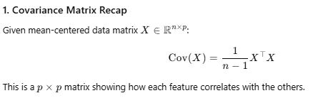
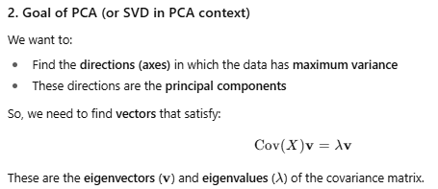
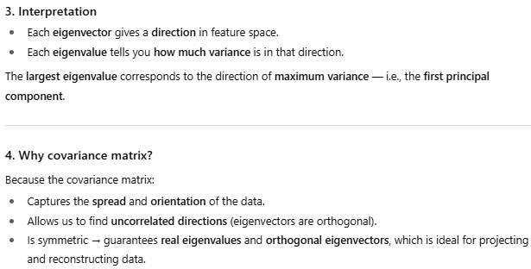
Concept | Role
Covariance matrix | Encodes how features vary with each other
Eigenvectors | Principal directions of variance
Eigenvalues | Magnitude of variance along those directions

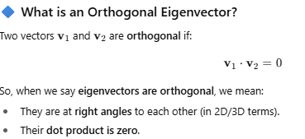

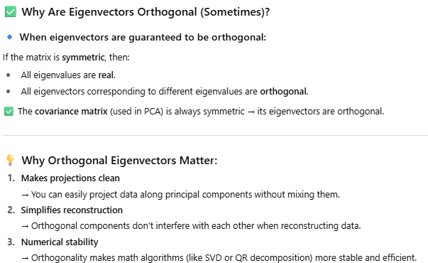

What is Sparse Data?
Sparse data refers to datasets where most values are zero, missing, or irrelevant.
In simple terms:
A dataset is sparse when a large portion of the data is empty or contains zero values.
Example of Sparse Data
Imagine a user-item matrix for a recommendation system (e.g., users rating movies):
 | Movie 1 | Movie 2 | Movie 3 | Movie 4
User A | 5 | 0 | 0 | 4
User B | 0 | 0 | 3 | 0
User C | 0 | 2 | 0 | 0

Most entries are 0 or blank → sparse matrix.
Common Examples of Sparse Data
Domain | Example
Recommendation Systems | User-item ratings, clicks
Natural Language Processing | Word occurrence in documents (bag-of-words, TF-IDF)
Computer Vision | Sparse pixel activations in some filters
Bioinformatics | Gene expression datasets

Tip
If you’re working with sparse data in Python:
from scipy.sparse import csr_matrix
sparse_mat = csr_matrix([[0, 0, 1], [1, 0, 0]])

This will save memory and speed up computation for large sparse datasets.

What is Bias Correction?
Bias correction refers to techniques used to adjust or remove bias in a dataset, model predictions, or statistical estimates to improve accuracy, fairness, and generalization.
What Is Bias?
In general:
Bias is a systematic error — a deviation from the true value — caused by faulty assumptions, sample imbalance, or measurement errors.
Types of Bias & Correction Strategies
Type of Bias | Where It Occurs | Bias Correction Methods
Data Bias | Biased training data (e.g. underrepresented groups) | Re-sampling (over/under-sampling), synthetic data generation (SMOTE)
Model Bias (Algorithmic) | Model favors certain outcomes | Regularization, ensemble methods, fairness constraints
Measurement Bias | Sensors, survey tools, instruments | Calibration, normalization, adjusting for known errors
Prediction Bias | Forecasts systematically off | Post-processing adjustments, bias-aware loss functions
Statistical Bias | Estimates not centered around true value | Bootstrapping, debiasing estimators, Bayesian correction

Example: Bias Correction in Machine Learning
Scenario:
A model predicting loan approvals consistently rejects applicants from a specific income group.

Bias correction methods:
- Rebalance the dataset so all income groups are fairly represented.
- Add fairness constraints during training.
- Evaluate with fairness metrics (e.g., Equal Opportunity, Demographic Parity).

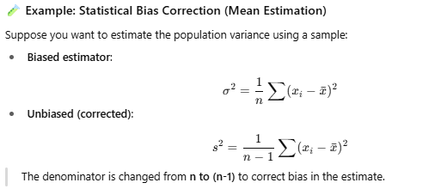
Bias Correction in Climate Models / Time Series
In forecasting (e.g., weather, financial markets), predictions can be systematically off from reality.
Correction method:
- Compute mean error (bias) over a historical period
- Subtract this bias from future predictions to adjust them

Why Bias Correction Matters
- Improves model fairness
- Enhances accuracy
- Ensures trustworthiness of decisions (especially in finance, healthcare, hiring)

🧠 Why Bias Happens
Deep learning models learn by finding statistical patterns in data. If the training data contains biases, imbalances, or stereotypes, the model will often replicate or even amplify those patterns because it optimizes for accuracy, not fairness.
For eg:
If a hiring model is trained on past company data where most hires were men, it might learn to favor male applicants.
A facial recognition system trained primarily on lighter-skinned faces may perform poorly on darker-skinned faces.

Types of Bias Introduced
Data bias – Unequal representation in training data (e.g., underrepresented groups).
Label bias – When human annotations reflect subjective or societal bias.
Measurement bias – When features are proxies for sensitive attributes (e.g., ZIP code as a proxy for race).
Algorithmic bias – When model design or optimization objectives favor certain outcomes.
🧩 Consequences
Discriminatory or unfair outcomes
Loss of trust in AI systems
Legal and ethical issues (especially in hiring, lending, policing, and healthcare)
🧰 Mitigation Strategies
Data Auditing & Preprocessing – Check for representational imbalance and correct it (e.g., re-sampling, data augmentation).
Fairness-Aware Algorithms – Incorporate fairness constraints or regularization during training.
Post-Processing Adjustments – Adjust model outputs to improve fairness metrics.
Human Oversight & Transparency – Combine automated predictions with human review and explainability tools.
Continuous Monitoring – Bias can reappear as data changes over time.

🎯 Scenario
Suppose we’re training a classifier to predict whether a loan should be approved (approved = 1) or not (approved = 0), based on features like income and credit score — but also gender, which is a sensitive attribute.
We want to check:
1. Whether the model’s predictions are biased by gender, and
2. How to mitigate that bias.
🧩 Step 1: Example Dataset
import pandas as pd
import numpy as np

# Synthetic dataset
np.random.seed(0)
n = 1000
df = pd.DataFrame({
'income': np.random.normal(50000, 15000, n),
'credit_score': np.random.normal(650, 50, n),
'gender': np.random.choice(['Male', 'Female'], size=n, p=[0.6, 0.4])
})

# Bias in labels: females have slightly lower approval rates
df['approved'] = ((df['income'] + df['credit_score'] / 2) > 65000).astype(int)
df.loc[df['gender'] == 'Female', 'approved'] = np.random.binomial(1, 0.4, sum(df['gender'] == 'Female'))

🧠 Step 2: Train a Simple Model
from sklearn.model_selection import train_test_split
from sklearn.preprocessing import LabelEncoder, StandardScaler
from sklearn.linear_model import LogisticRegression
from sklearn.metrics import accuracy_score

# Encode gender
le = LabelEncoder()
df['gender_code'] = le.fit_transform(df['gender'])

X = df[['income', 'credit_score', 'gender_code']]
y = df['approved']

X_train, X_test, y_train, y_test = train_test_split(X, y, test_size=0.3, random_state=42)

scaler = StandardScaler()
X_train = scaler.fit_transform(X_train)
X_test = scaler.transform(X_test)

model = LogisticRegression()
model.fit(X_train, y_train)

preds = model.predict(X_test)
print("Accuracy:", accuracy_score(y_test, preds))

⚖️ Step 3: Detect Bias
We’ll use a fairness metric — the demographic parity difference, which measures how prediction rates differ across groups.

test = pd.DataFrame(X_test, columns=['income', 'credit_score', 'gender_code'])
test['approved_pred'] = preds
test['gender'] = le.inverse_transform(test['gender_code'].astype(int))

group_rates = test.groupby('gender')['approved_pred'].mean()
dp_diff = abs(group_rates['Male'] - group_rates['Female'])

print("Approval rate by gender:")
print(group_rates)
print(f"Demographic Parity Difference: {dp_diff:.3f}")

If you see something like:
Male: 0.70
Female: 0.42
Demographic Parity Difference: 0.28
→ That indicates significant bias.

🧰 Step 4: Mitigate Bias (Preprocessing Example)
One simple method is reweighing, where we assign different sample weights to balance group fairness.
from sklearn.utils.class_weight import compute_sample_weight

weights = compute_sample_weight('balanced', df['gender'])
model_fair = LogisticRegression()
model_fair.fit(X_train, y_train, sample_weight=weights[:len(X_train)])

preds_fair = model_fair.predict(X_test)
test['approved_pred_fair'] = preds_fair

group_rates_fair = test.groupby('gender')['approved_pred_fair'].mean()
dp_diff_fair = abs(group_rates_fair['Male'] - group_rates_fair['Female'])

print("After fairness reweighing:")
print(group_rates_fair)
print(f"Demographic Parity Difference: {dp_diff_fair:.3f}")

If the difference drops (e.g., from 0.28 → 0.10), bias has been reduced.
✅ Step 5: Interpret Results
Before mitigation: The model favoured males in predictions.
After mitigation: The approval rate gap between genders narrowed.
Trade-off: Slight drop in accuracy, but improved fairness.
📊 Bonus: Fairness Libraries
You can use dedicated fairness libraries to make this easier:
Fairlearn
AIF360 (IBM)
Fairness Indicators (Google)

These provide metrics like:
Demographic parity
Equalized odds
Predictive parity
Disparate impact

🧠 What Is Data Augmentation?
Data augmentation means creating new, slightly modified versions of your existing training data — without collecting new samples.
The idea is to help your model see more diverse examples, so it doesn’t overfit or learn unwanted biases that might be present in limited or unbalanced datasets.
Why It Matters
Limited Data: Creates Synthetic variation to expand the training Data
Class Imbalance: Balances UnderRepresented Classes
Model Bias: Introduces Diversity to reduce over -reliance on specific patterns
Overfitting: Encourages model to generalize instead of memorizing

🖼️ Example: Image Data Augmentation
In PyTorch
from torchvision import transforms

transform = transforms.Compose([
transforms.RandomHorizontalFlip(p=0.5),
transforms.RandomRotation(10),
transforms.ColorJitter(brightness=0.2, contrast=0.2, saturation=0.2),
transforms.RandomResizedCrop(size=224, scale=(0.8, 1.0)),
transforms.ToTensor()
])
These transformations:
Flip images horizontally
Rotate slightly
Change brightness, contrast, and color
Randomly crop and resize
This helps the model handle pose, lighting, and orientation changes — making it less biased toward specific visual conditions.
🧍 Example: Text Data Augmentation (NLP)
Text data can be augmented with:
Synonym replacement: Replace words with synonyms
Back-translation: Translate text to another language and back
Random deletion/insertion: Randomly drop or insert words
Example (using nlpaug library):
import nlpaug.augmenter.word as naw

aug = naw.SynonymAug(aug_src='wordnet')
sentence = "The customer is happy with the product."
augmented = aug.augment(sentence)
print(augmented)

Output might be:
“The client is pleased with the product.”
This increases linguistic diversity and reduces bias from language style or phrasing.

Example: Tabular Data Augmentation
For structured data (e.g., in fairness-sensitive models):
SMOTE (Synthetic Minority Oversampling Technique) can create synthetic samples for underrepresented classes.
from imblearn.over_sampling import SMOTE
from sklearn.datasets import make_classification

X, y = make_classification(n_classes=2, weights=[0.8, 0.2], random_state=42)
sm = SMOTE(random_state=42)
X_res, y_res = sm.fit_resample(X, y)

Now, the minority class is better represented → reducing bias.

Data Augmentation for Fairness
Augmentation can be targeted to reduce bias:
Generate more samples of underrepresented groups (e.g., darker skin tones, female voices, minority languages).
Apply transformations evenly across all classes.
Use synthetic data generation (e.g., GANs) to improve representation.
However, you must validate that augmented data doesn’t introduce new artifacts or unrealistic patterns.
Summary
Aspect | Description
Goal | Increase data diversity and reduce bias
Common in | Images, text, speech, tabular data
Helps with | Fairness, generalization, robustness
Tools | PyTorch `transforms`, TensorFlow `ImageDataGenerator`, `nlpaug`, `imblearn`

Know further on “how image data augmentation changes pictures before training)?”

DropOut
dropout is one of the most effective and widely used techniques to prevent overfitting in deep learning models.
Let’s go step by step so you understand what dropout does, why it works, and how to use it in practice (PyTorch + TensorFlow examples) 👇

🧠 What Is Overfitting?
Overfitting happens when your model learns the noise and specific details in the training data instead of general patterns.
This leads to:
• Very high accuracy on training data ✅
• Poor performance on unseen/test data ❌

Goal: Help the model generalize better.

💡 What Is Dropout?
Dropout randomly “turns off” (sets to zero) a fraction of the neurons during training.
For example:
• You might set a dropout rate of 0.5
• That means half the neurons are randomly deactivated in each training pass
This prevents neurons from relying too heavily on specific other neurons — forcing the network to learn redundant, more general representations.
⚙️ How Dropout Works
Let’s say your layer output is a vector:
[0.2, 0.5, 0.7, 0.9]
With a dropout rate of 0.5, about half of these activations are zeroed during training:
[0, 0.5, 0, 0.9]
During inference (testing), dropout is disabled, but the activations are scaled down by the dropout rate to maintain balance.
🧩 Using Dropout in PyTorch
import torch
import torch.nn as nn
import torch.nn.functional as F

class SimpleNet(nn.Module):
def __init__(self):
super(SimpleNet, self).__init__()
self.fc1 = nn.Linear(784, 256)
self.dropout = nn.Dropout(p=0.5) # Dropout with 50% probability
self.fc2 = nn.Linear(256, 10)

def forward(self, x):
x = F.relu(self.fc1(x))
x = self.dropout(x) # Apply dropout only during training
x = self.fc2(x)
return x

model = SimpleNet()
print(model)

➡️ When you call model.train(), dropout is active.
➡️ When you call model.eval(), dropout is disabled automatically.

🧮 Using Dropout in TensorFlow / Keras
from tensorflow.keras.models import Sequential
from tensorflow.keras.layers import Dense, Dropout

model = Sequential([
Dense(256, activation='relu', input_shape=(784,)),
Dropout(0.5), # 50% dropout rate
Dense(10, activation='softmax')
])

⚖️ Choosing the Dropout Rate

Layer Type | Typical Dropout Rate
Input Layer | 0.1 – 0.2
Hidden Layers | 0.3 – 0.5
Recurrent Layers (LSTM/GRU) | 0.1 – 0.3

Too high → underfitting.
Too low → overfitting may persist.
Tune it with validation performance.
Complementary Anti-Overfitting Techniques
Dropout works best when combined with:
- Early stopping – Stop training when validation loss stops improving
- Data augmentation – Increase diversity of training data
- Regularization (L1/L2) – Penalize overly large weights
- Batch normalization – Stabilize learning dynamics
✅ Summary
Concept | Explanation
Dropout | Randomly disables neurons during training
Goal | Prevent over-reliance on specific neurons (reduce overfitting)
When active | Only during training
Benefits | Better generalization, robustness
Trade-off | Slightly slower convergence, requires tuning

Would you like me to show a graphical illustration (e.g., before vs. after dropout on a neural network’s activations)?

-------************-------------
LIME: Local Interpretable Model-agnostic Explanations
one of the most popular techniques for interpreting complex (black-box) machine learning models like deep learning, random forests, or ensemble models.
What is LIME?
LIME (Local Interpretable Model-agnostic Explanations) is a method that explains individual predictions made by any machine learning model — no matter how complex it is.
The key ideas are:
• Model-agnostic → works with any classifier or regressor (deep learning, tree-based, etc.)
• Local explanation → explains why the model made a specific prediction for a specific instance (not the whole dataset)
Why We Need It
Deep learning models are powerful but opaque — we often don’t know why they make a certain prediction.
LIME helps by:
• Increasing trust and transparency
• Helping identify bias or spurious correlations
• Supporting model debugging and regulatory compliance (e.g., in finance or healthcare)
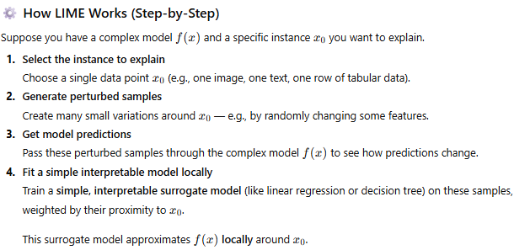
🧩 Example in Python
Let’s use a classification model and explain it with LIME.
from sklearn.datasets import load_iris
from sklearn.model_selection import train_test_split
from sklearn.ensemble import RandomForestClassifier
from lime.lime_tabular import LimeTabularExplainer

# Load data
data = load_iris()
X_train, X_test, y_train, y_test = train_test_split(data.data, data.target, random_state=42)

# Train model
model = RandomForestClassifier()
model.fit(X_train, y_train)

# Create LIME explainer
explainer = LimeTabularExplainer(
training_data=X_train,
feature_names=data.feature_names,
class_names=data.target_names,
mode='classification'
)

# Pick one instance to explain
i = 5
exp = explainer.explain_instance(X_test[i], model.predict_proba)

# Show explanation
exp.show_in_notebook(show_table=True)

✅ This will show a local explanation highlighting which features (e.g., petal width, sepal length) influenced the prediction and by how much.

📊 Example Output Interpretation
For an instance classified as “Iris-versicolor,” you might see:
Feature | Weight | Effect
Petal width (cm) > 1.5 | 0.35 | Supports prediction
Sepal width (cm) ≤ 3.0 | -0.12 | Opposes prediction

This tells you which specific feature values pushed the model toward that class.
🧮 Where LIME Works
Data Type | Library Used
Tabular | LimeTabularExplainer
Text | LimeTextExplainer
Images | LimeImageExplainer

⚖️ Strengths and Limitations
✅ Advantages
- Model-agnostic
- Local explanations are intuitive
- Works on images, text, and tabular data
- Easy to integrate into ML workflows
⚠️ Limitations
- Only explains one instance at a time (local, not global)
- Results can vary (stochastic perturbations)
- Computationally expensive for large models
- Doesn’t guarantee global faithfulness to model behavior

🧰 Common Alternatives
If you’re interested in model explainability more broadly, you might also look at:
Technique | Description
SHAP (SHapley Additive exPlanations) | Game-theoretic approach; globally consistent
Integrated Gradients | Attribution method for neural networks
Grad-CAM | Visual explanation for CNNs (images)
Anchors | Extension of LIME that gives rule-based explanations

✅ Summary
Concept | Description
Full Name | Local Interpretable Model-agnostic Explanations
Purpose | Explain predictions of any black-box model locally
Approach | Approximate complex model with simple local model
Output | Feature-level explanation for one prediction
Library | lime (Python)

Would you like me to show a visual example (e.g., how LIME explains an image classifier’s prediction)?
-------********----------------

Fairness-aware machine learning is an essential and growing field focused on ensuring that AI systems make equitable and unbiased decisions across different groups of people (e.g., gender, race, age, etc.).
Let’s go through this step-by-step so you get a complete understanding — from the concepts to practical techniques and tools 👇
What Is Fairness-Aware Machine Learning?
Fairness-aware ML involves designing, training, and evaluating models so that predictions are fair and unbiased with respect to protected or sensitive attributes (e.g., gender, race, age, religion).

In short,
Fairness-aware ML = High accuracy ✅ + Equal treatment across groups ⚖️
⚖️ Why It Matters
Without fairness interventions, models can:
Discriminate against underrepresented or marginalized groups
Amplify biases in historical data
Lead to legal, ethical, and reputational risks
For example:
A hiring model preferring men due to biased historical data
A facial recognition system misidentifying darker-skinned individuals
A loan model rejecting certain ZIP codes (proxy for race)

🧩 Core Fairness Concepts
Fairness Type | Meaning | Example
Demographic Parity | All groups receive positive outcomes at the same rate | Equal loan approval rate across genders
Equal Opportunity | True positive rate is equal across groups | Same chance of approval if truly qualified
Equalized Odds | Equal true and false positive rates | Balanced model errors across groups
Predictive Parity | Positive predictions are equally accurate | Equal precision for all groups
Individual Fairness | Similar individuals → similar predictions | Two applicants with same profile → same result

🧰 Fairness-Aware ML Workflow
Let’s break the full process into five stages:
1️⃣ Data Collection & Preprocessing
Bias often starts here.
Practices:
- Audit data for representation gaps
- Balance datasets (e.g., oversample underrepresented groups with SMOTE)
- Remove or mask sensitive attributes when appropriate
- Create fairness-aware features (avoid proxies like ZIP codes)
- Use data augmentation to increase diversity

2️⃣ Fairness-Aware Training
Integrate fairness constraints directly during model training.
Techniques:
- Reweighing: Assign sample weights to balance groups
- Adversarial debiasing: Train a model to predict target labels while preventing another model from inferring protected attributes
- Fair regularization: Add a penalty term for unfair outcomes

Example :
# Fairlearn example (adversarial debiasing)
from fairlearn.reductions import ExponentiatedGradient, DemographicParity
from sklearn.linear_model import LogisticRegression

estimator = LogisticRegression(solver='liblinear')
constraint = DemographicParity()
mitigator = ExponentiatedGradient(estimator, constraint)
mitigator.fit(X_train, y_train, sensitive_features=df['gender'])

3️⃣ Post-Processing Adjustments
After model training, modify the output to reduce unfairness.
Methods:
- Equalized odds post-processing
- Reject option classification (change decision thresholds for groups)
- Calibrated equalized odds
These adjust predictions without retraining the model.

4️⃣ Fairness Evaluation
Measure fairness using fairness metrics along with accuracy metrics.
Metrics Examples:
Metric | Description
Demographic Parity Difference (DPD) | Difference in positive prediction rates between groups
Equal Opportunity Difference (EOD) | Difference in true positive rates
Disparate Impact (DI) | Ratio of group positive rates (should be close to 1)

Code Example (Fairlearn):
from fairlearn.metrics import MetricFrame, selection_rate, true_positive_rate

metrics = MetricFrame(
metrics={'selection_rate': selection_rate, 'true_positive_rate': true_positive_rate},
y_true=y_test, y_pred=preds, sensitive_features=df_test['gender']
)

print(metrics.by_group)

5️⃣ Transparency, Accountability & Monitoring
- Provide model explanations using tools like LIME or SHAP
- Conduct bias audits regularly as data changes
- Keep documentation (model cards, datasheets) to describe how fairness is maintained
- Engage human oversight in critical decision processes
🧮 Tools and Libraries
Library | Use Case
Fairlearn (Microsoft) | Fairness metrics, constraints, visualization
AIF360 (IBM) | Full pipeline for bias detection & mitigation
Fairness Indicators (Google) | TensorFlow model fairness evaluation
What-If Tool | Interactive visualization for model fairness
SHAP / LIME | Explainability and local bias inspection

Example Workflow Summary
Stage | Action | Example Tool
Data | Audit & balance data | pandas, SMOTE
Training | Add fairness constraint | fairlearn.reductions
Evaluation | Compute fairness metrics | MetricFrame
Interpretation | Explain model | LIME, SHAP
Governance | Document fairness efforts | Model Cards

⚖️ Trade-offs to Consider
Fairness often comes with trade-offs between:
- Accuracy vs. Fairness: Some performance loss may occur when improving fairness
- Group vs. Individual Fairness: Optimizing one may reduce the other
- Short-term vs. Long-term Fairness: Interventions may have evolving impacts

✅ Summary

Aspect | Description
Goal | Ensure ML systems make unbiased, equitable decisions
Approach | Fairness in data, training, and evaluation
Key Techniques | Reweighing, Adversarial Debiasing, Post-processing
Metrics | Demographic parity, Equalized odds, Disparate impact
Tools | Fairlearn, AIF360, SHAP, LIME

----**********----------------

What Is Mean Error?
Mean Error (ME) is a simple statistical metric that measures the average difference between predicted values and actual values:

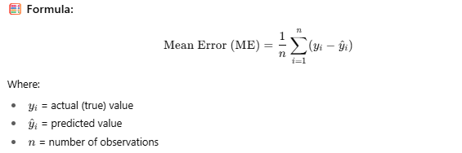
What It Tells You:
- If ME = 0 → On average, your model is unbiased (under- and over-predictions cancel out)
- If ME > 0 → The model under-predicts on average
- If ME < 0 → The model over-predicts on average
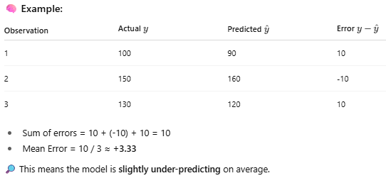
Important Note:
Mean Error can be misleading because positive and negative errors cancel out. So we often use:
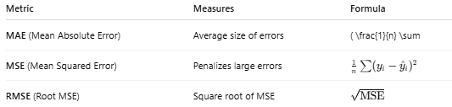

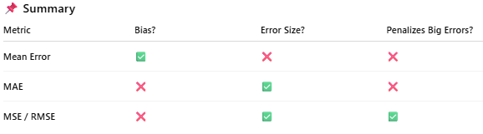

What is MAE (Mean Absolute Error)?
MAE measures the average magnitude of errors in predictions, without considering their direction (sign). It tells you how far off your predictions are from the actual values on average.

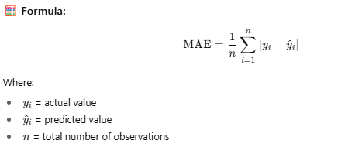

What It Tells You:
- The average absolute difference between prediction and actual values.
- Lower MAE means better prediction accuracy.
- Unlike Mean Error (ME), MAE does not cancel out positive and negative errors.

Observation | Actual y | Predicted $\hat{y}$​ | Error |y−$\hat{y|}$​​ | Squared Error  $${(y-\hat{y}​)}^{2}$$
1 | 100 | 90 | 10 | 100
2 | 150 | 175 | 25 | 625
3 | 130 | 113 | 17 | 289

Sum of absolute errors : 10+25+17 =52
MAE=52/3 =17.33
This means your predictions are off by an average of 17.33 units

Why Use MAE?
- Easy to interpret (same units as original data)
- Less sensitive to outliers than MSE/RMSE
- Good choice when you want equal weight for all errors

What is MSE (Mean Squared Error)?
MSE measures the average of the squared differences between actual values and predicted values.
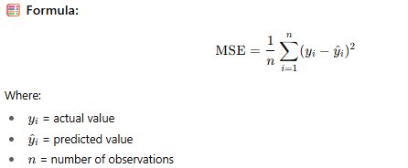
What It Tells You:
- How far predictions deviate from actual values, penalizing larger errors more because errors are squared.
- Smaller MSE means better model performance.
Observation | Actual y | Predicted $\hat{y}$​ | Mean Error (y−$\hat{y}$​​)/n | Mean Absolute Error | y−$\hat{y}$|/n | Mean Squared Error  ${(y-\hat{y}​)}^{2}$/n | Root Mean Squared Error  $$\sqrt{{(y-\hat{y}​)}^{2}/n}$$
1 | 100 | 90 | 10 | 10 | 100 | 100
2 | 150 | 175 | -25 | 25 | 625 | 625
3 | 130 | 113 | 17 | 17 | 289 | 289
Avg |  |  | 0.666667 | 17.33333 | 338 | 18.38

Sum of squared errors = 100 + 625 + 289 = 1014
MSE = 1014 / 3 = 338
Why Use MSE?
- Penalizes larger errors more than smaller ones — good when big mistakes are particularly undesirable.
- Useful in many optimization algorithms because it's differentiable and smooth.
- Commonly used in regression problems
Note:
- MSE’s unit is squared (e.g., squared dollars), so it’s less interpretable compared to MAE.
- RMSE (Root Mean Squared Error) is often used to get the error back in original units:

RMSE=sqrt(MSE) => sqrt(338)=18.38

1. Regularization
Purpose: Prevents overfitting by adding a penalty for complex models (large coefficients), encouraging simpler models that generalize better.
- Types:
  - L1 Regularization (Lasso): Adds sum of absolute coefficients penalty. Can shrink some coefficients to zero → feature selection.
  - L2 Regularization (Ridge): Adds sum of squared coefficients penalty. Shrinks coefficients smoothly but none to zero.
  - Elastic Net: Combination of L1 and L2.
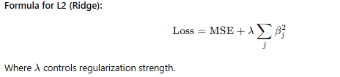
Regularization adds a penalty term to the loss function to prevent the model from overfitting (i.e., memorizing training data).
Why?
- Controls model complexity
- Helps generalize better on unseen data
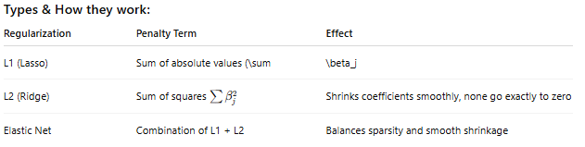

Python example: Ridge regression with sklearn
from sklearn.linear_model import Ridge
from sklearn.model_selection import train_test_split
from sklearn.metrics import mean_squared_error

# Sample data
X_train, X_test, y_train, y_test = train_test_split(X, y, test_size=0.2)

# Ridge Regression with alpha (regularization strength)
ridge = Ridge(alpha=1.0)
ridge.fit(X_train, y_train)

preds = ridge.predict(X_test)
print("MSE:", mean_squared_error(y_test, preds))

2. Ensemble Methods
Purpose: Combine predictions from multiple models to improve accuracy, robustness, and reduce variance or bias.
- Popular Techniques:
  - Bagging: Train multiple models on random subsets (e.g., Random Forest).
  - Boosting: Sequentially train models focusing on errors of previous models (e.g., AdaBoost, XGBoost).
  - Stacking: Combine different models’ outputs using a meta-model.

What are they?
Combine multiple models to improve performance.
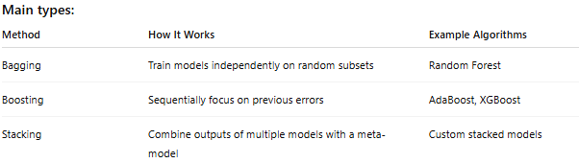
Why?
- Reduces variance (bagging)
- Reduces bias (boosting)
- Increases robustness and accuracy

Python example: Random Forest
from sklearn.ensemble import RandomForestClassifier
from sklearn.metrics import accuracy_score

rf = RandomForestClassifier(n_estimators=100)
rf.fit(X_train, y_train)

preds = rf.predict(X_test)
print("Accuracy:", accuracy_score(y_test, preds))

3. Fairness Constraints
Purpose: Ensure machine learning models do not discriminate or create unfair bias towards certain groups.
- Approaches:
  - Pre-processing: Balance or re-weight training data.
  - In-processing: Add fairness constraints or regularization terms directly in model training (e.g., equalized odds, demographic parity).
  - Post-processing: Adjust predictions to meet fairness goals after training.
- Metrics to check fairness:
  - Demographic Parity
  - Equal Opportunity
  - Equalized Odds
Why these matter:
- Regularization: Keeps models simple, reduces overfitting, improves generalization.
- Ensembles: Boost model performance and stability.
- Fairness Constraints: Build ethical, responsible AI without discrimination.

What is it?
Techniques to ensure ML models do not discriminate based on sensitive attributes (gender, race, etc.).
When to use?
When fairness and ethical AI is critical (e.g., hiring, lending).
How to measure fairness?
Metric | What it measures
Demographic Parity | Equal positive rates across groups
Equal Opportunity | Equal true positive rates across groups
Equalized Odds | Equal true and false positive rates

How to implement?
- Preprocessing: Balance dataset with oversampling, re-weighting
- In-processing: Add fairness constraints in loss function (more advanced)
- Postprocessing: Adjust predictions to meet fairness goals
Python example: Using fairlearn for fairness assessment
from fairlearn.metrics import MetricFrame, selection_rate
import pandas as pd

# y_true: true labels, y_pred: predictions, sensitive_feature: e.g., gender
metric_frame = MetricFrame(metrics=selection_rate,
y_true=y_true,
y_pred=y_pred,
sensitive_features=sensitive_feature)

print(metric_frame.by_group)
Summary
Concept | Purpose | Example Library
Regularization | Prevent overfitting | sklearn.linear_model
Ensemble Methods | Improve accuracy & robustness | sklearn.ensemble
Fairness Constraints | Ensure ethical, unbiased models | fairlearn, AIF360

Manual Example: Ridge Regression (L2 Regularization)
Let’s manually walk through how regularization (Ridge regression) works on a small sample dataset, step-by-step, including the calculations.
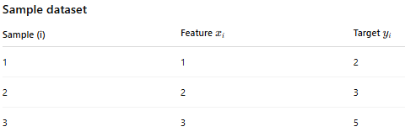
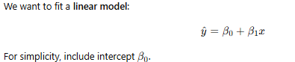
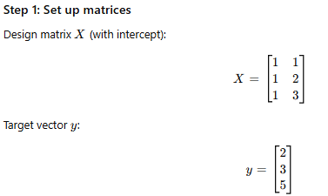
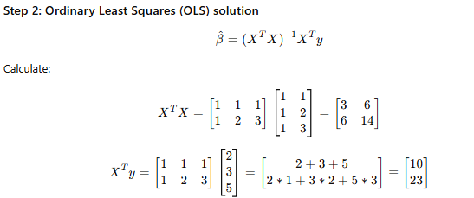

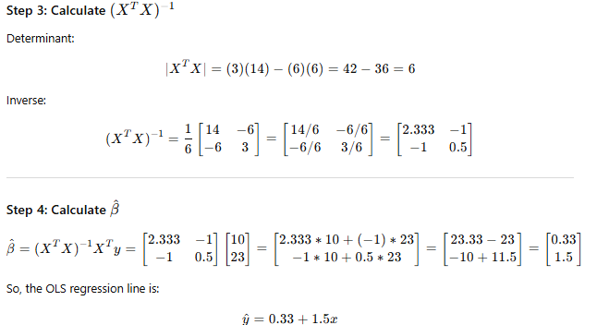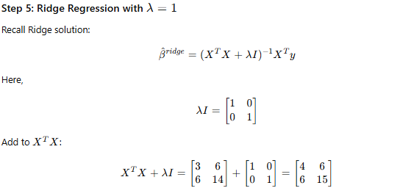

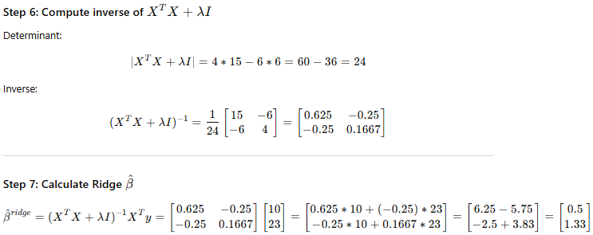
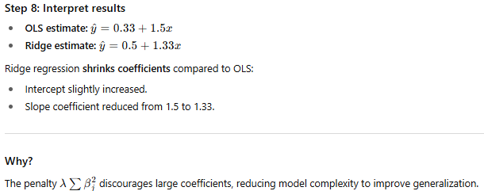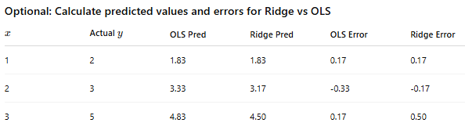
Summary:
- Regularization trades off a bit of training error for better generalization.
- Ridge shrinks coefficients to prevent overfitting.
- You can manually compute these with small datasets!

Let’s extend the manual Ridge regression example to multiple features. We’ll walk through the whole process with 2 features + intercept.

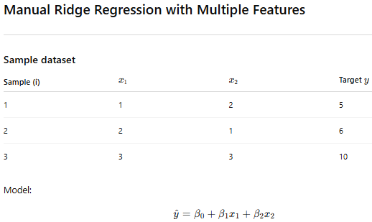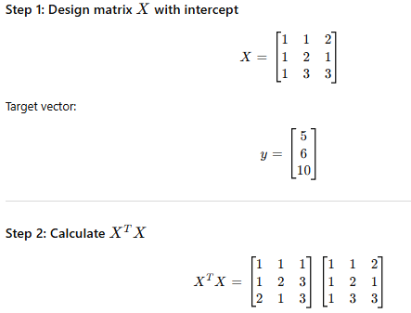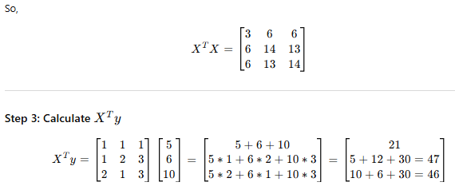
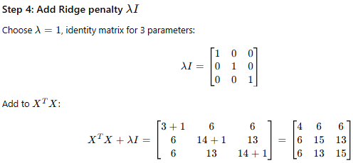
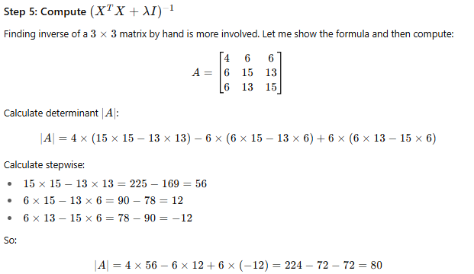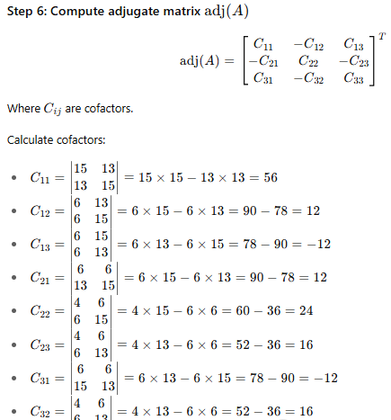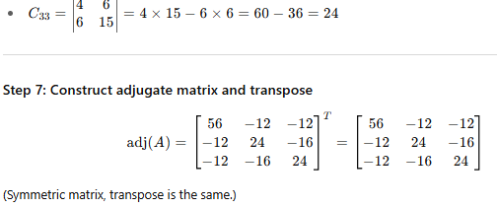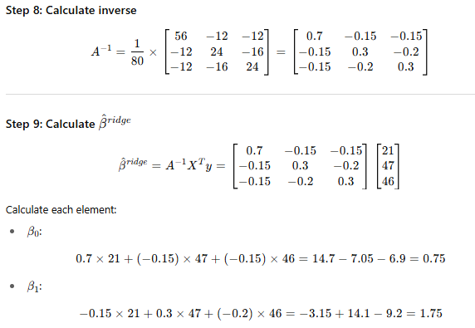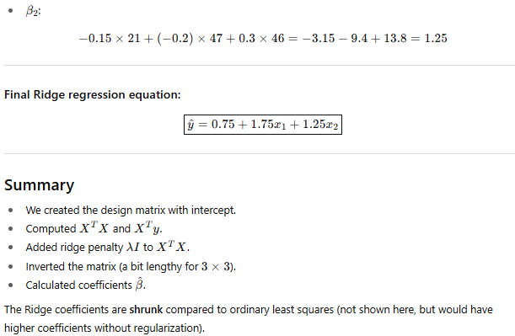
Let’s calculate the Ordinary Least Squares (OLS) coefficients for the same dataset to compare with the Ridge regression results.

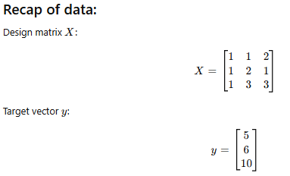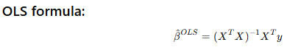
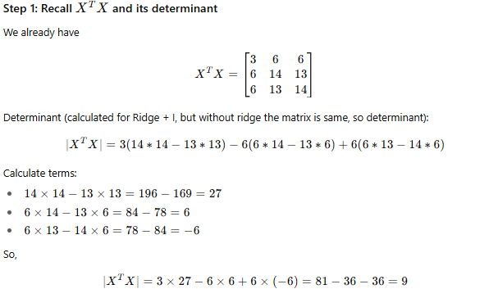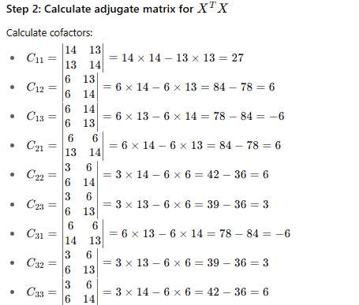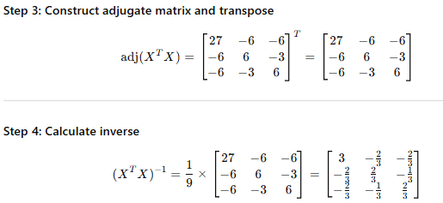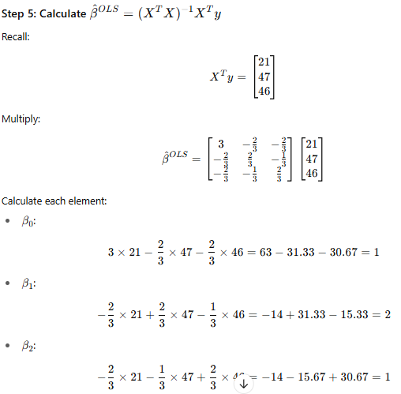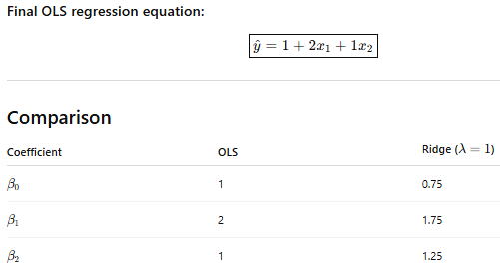Interpretation:
- Ridge shrinks coefficients towards zero (smaller magnitude) to reduce overfitting.
- Intercept also slightly shifts.
- The shrinkage depends on λ; larger λ means more shrinkage.

What is Elastic Net?
Elastic Net is a regularization technique that combines both:
- L1 penalty (Lasso) — encourages sparsity (feature selection).
- L2 penalty (Ridge) — encourages small coefficients and stability.
It’s useful when you want the benefits of both: selecting important features and reducing coefficient magnitude to avoid overfitting.
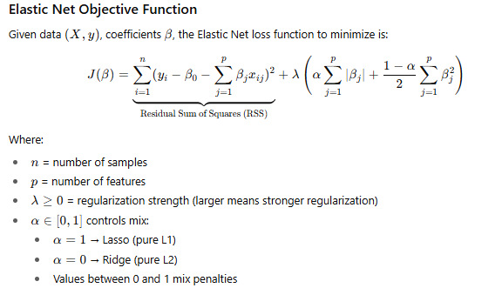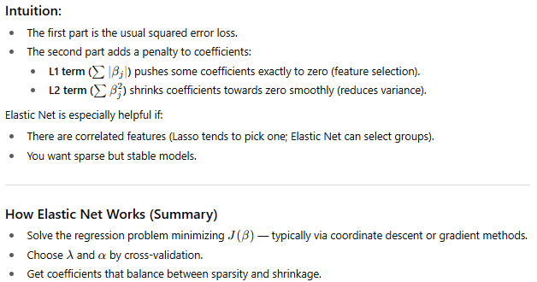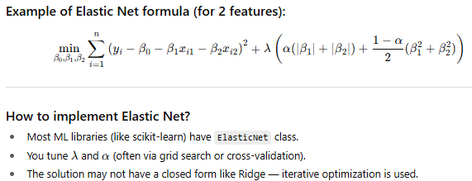

Let’s walk through a manual, simple example of Elastic Net regression with a tiny dataset and two features.
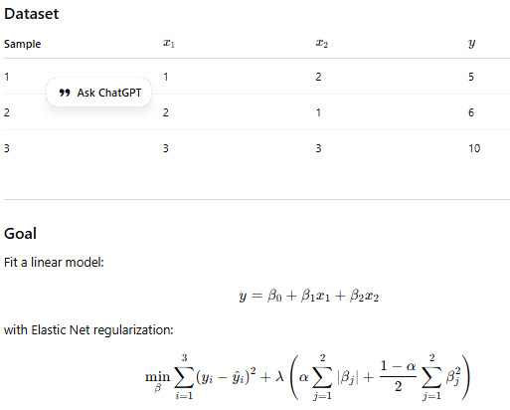
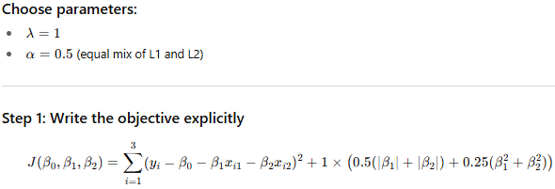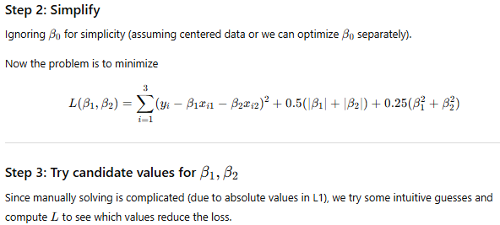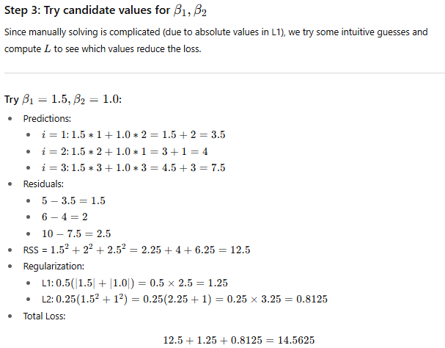
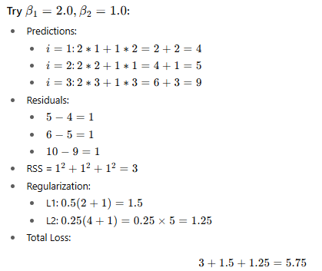
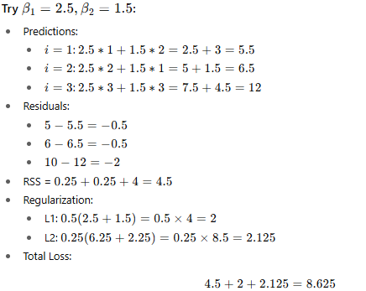
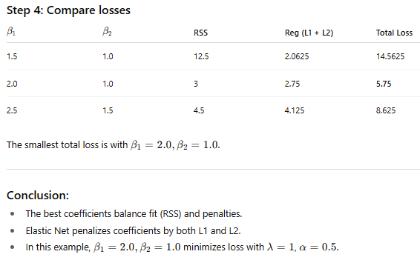

How to solve Elastic Net with coordinate descent.

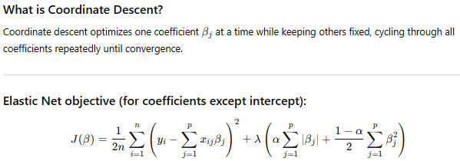

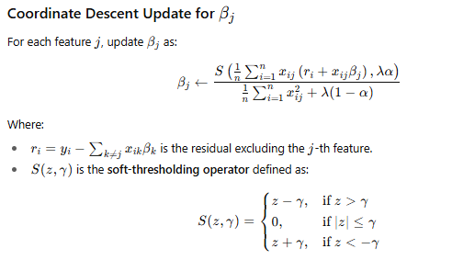
Intuition:
- The numerator calculates the partial residual correlation with feature jjj.
- The soft-thresholding applies shrinkage and can set coefficients exactly to zero (L1 effect).
- The denominator includes feature variance plus Ridge penalty (L2).

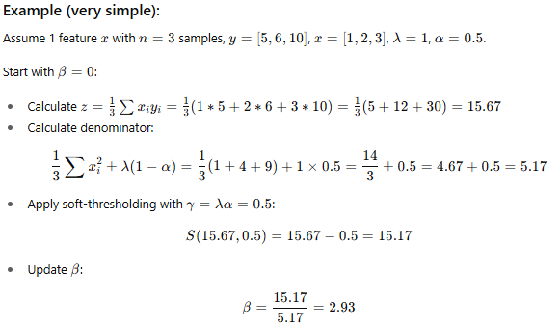
This process continues cycling through all features until convergence.

Explain the soft-thresholding operator with graphs/examples?
Let me explain the soft-thresholding operator with intuitive examples and a graph. It’s key to understanding how L1 regularization (like in Lasso and Elastic Net) works.
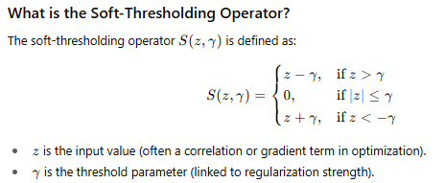
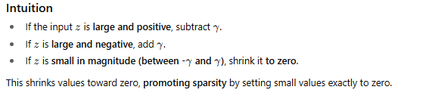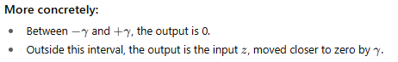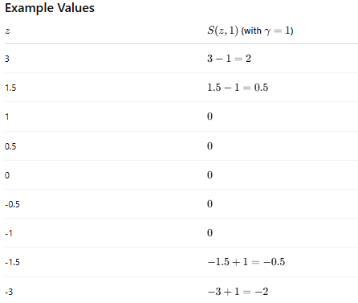
Why is it important in Elastic Net/Lasso?
- During coefficient updates, soft-thresholding shrinks small coefficients to zero, effectively performing feature selection.
- It’s the mathematical step that enforces sparsity.
- Larger γ\gammaγ (stronger regularization) means more coefficients get zeroed out.

Difference between Intercept and Offset

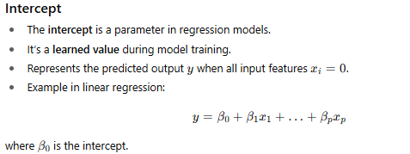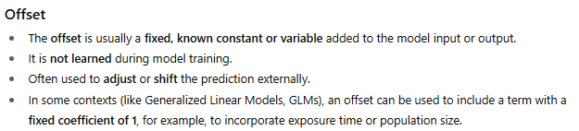
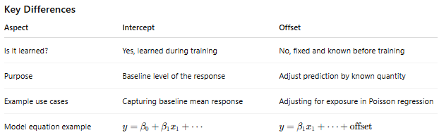
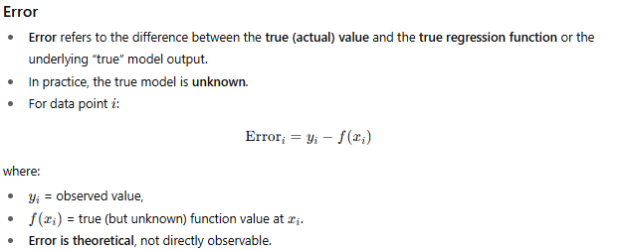
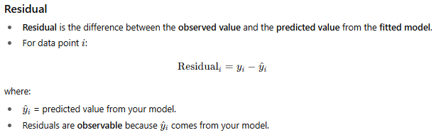
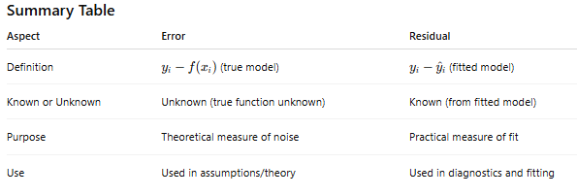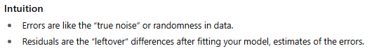

A closed-form solution is an exact, explicit mathematical expression for the answer to a problem — one that can be written using a finite combination of standard operations and functions.
It is the opposite of needing numerical methods (like iteration, approximation, optimization, or simulation).
1. Formal Definition
A closed-form solution is an expression that uses a finite number of:
- constants
- variables
- arithmetic operations (+, −, ×, ÷)
- exponentials, logarithms
- roots
- trigonometric functions
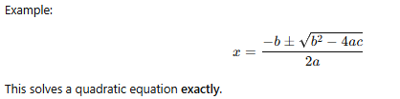
🚫 If a solution cannot be expressed this way, we say:
- “No closed-form solution” or
- “Must be solved numerically”
Examples:
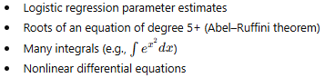
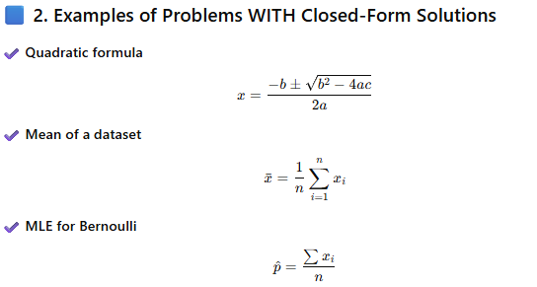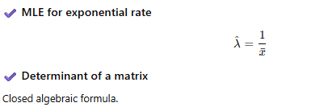
🟥 3. Examples of Problems WITHOUT Closed-Form Solutions
(These require numerical/iterative methods.)
❌ Logistic regression coefficients
No algebraic formula. Must use MLE via gradient descent, Newton-Raphson, etc.
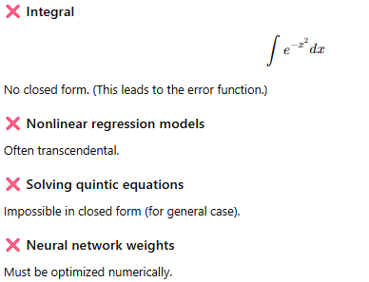

🔥 4. Why Closed-Form Solutions Are Important
They allow:
- exact answers
- fast computation
- high reliability
- deep analytical understanding
They are preferred when they exist, but often impossible for complex real-world problems.
🎯 5. Simple Definition (Very Easy)
👉 Closed-form solution = exact formula that you can write down.
👉 No closed-form solution = must solve by approximation.

Feature | Closed-Form | Non-Closed-Form
Formula | Yes | No
Computation | Direct | Iterative/Numerical
Accuracy | Exact | Approximate
Examples | Quadratics, simple MLE | Logistic regression, complex integrals

What “Transcendental” Means
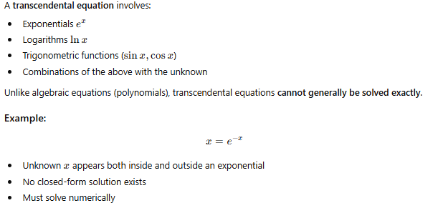
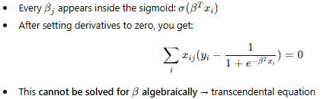
Implication
Because of this transcendental nature:
- Logistic regression has no closed-form solution
- Must use numerical methods:
  - Gradient descent
  - Newton-Raphson
  - Iteratively reweighted least squares (IRLS)
Quick Intuition
Linear regression: derivative = linear in 𝛽
β → can invert matrices → closed form
Logistic regression: derivative = contains sigmoid (exponential) → unknown inside and outside exp → transcendental → no closed form

what is the purpose of quadratic function
A quadratic function is a fundamental mathematical tool with a wide range of purposes in mathematics, science, engineering, and machine learning. Let’s break it down clearly.
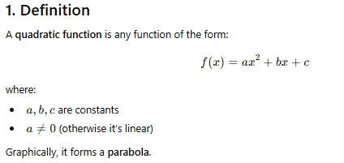

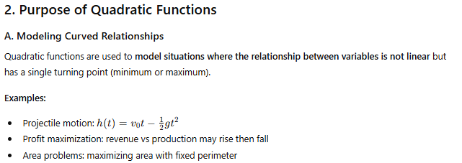
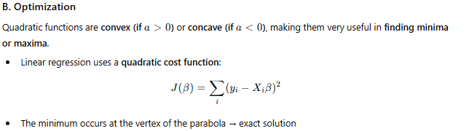

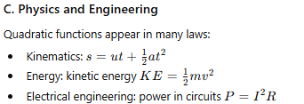
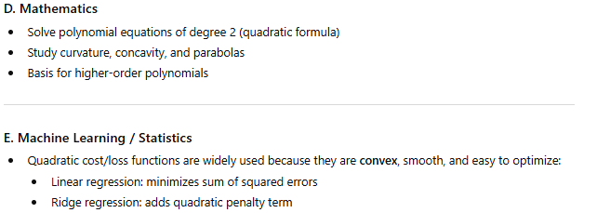
Feature | Purpose / Role
Parabola shape | Models turning points (min/max)
Convexity | Guarantees global minimum
Smooth derivative | Easy for optimization algorithms
Simple formula | Exact analytical solutions possible

4. Intuitive Analogy
- Imagine throwing a ball: its height vs time forms a parabola → quadratic function models this perfectly.
- Quadratic functions describe “curves that bend once”: first slope changes from positive to negative (or vice versa).

5. Quick Summary
Quadratic functions are used for:
- Modeling curved relationships
- Optimization (finding min/max)
- Physics and engineering equations
- Statistical cost functions
- Polynomial foundations for higher-order math

Why Real world noise tends to be Gaussian ?
Real-world noise often appears Gaussian because of a fundamental statistical principle: the Central Limit Theorem (CLT).
Here is a clear explanation:
✅ 1. Central Limit Theorem (Main Reason)
Most real-world noise is not caused by just one source—it’s caused by many small, independent, random disturbances happening at the same time.
Examples of small disturbances:
- tiny fluctuations in temperature
- electrical resistance variations
- vibration
- air molecule collisions
- random electron movement
Each disturbance contributes a small amount of noise.
According to the Central Limit Theorem:
If many small, independent random effects add together,
their sum tends to follow a Gaussian (normal) distribution,
no matter what distribution each effect individually has.
Since real-world noise is usually the sum of many tiny effects, the resulting noise is approximately Gaussian.

✅ 2. Additive Effects → Gaussian Noise
Most noise sources add to the signal rather than multiply it.
Additive systems combine disturbances like this:
When a large number of small noises combine → normal distribution appears.

✅ 3. No single source dominates
Gaussian noise appears when:
- no single noise source is overwhelmingly stronger than others
- the total noise is the accumulation of many small effects
This matches many real systems: sensors, electronic circuits, communication channels, etc.

✅ 4. Physical processes naturally produce Gaussian-like randomness
Many natural processes (e.g., Brownian motion, thermal agitation of electrons) inherently produce variations that follow a normal distribution.
Examples:
- thermal noise in resistors is exactly Gaussian
- shot noise in photodiodes approximates Gaussian when aggregated
🧠 Intuition
Imagine 100 tiny random pushes on a signal—some push up, some push down.
Individually, they’re unpredictable, but the combined effect tends to form a bell curve.
Just like how:
- height of a person
- test score variations
- measurement errors
end up being normally distributed.

📌 Summary
Real-world noise is Gaussian because:
- Central Limit Theorem
– many small independent factors add up → normal distribution
- Most noise sources are additive
- No single noise source dominates
- Physical processes naturally generate Gaussian-like variations

Difference between Gaussian and Additive White Gaussian Noise
Gaussian noise = “values have a bell-shaped distribution.”
White Gaussian noise = “values have a bell-shaped distribution AND no correlation AND equal power everywhere.”

How could a white gaussian noise follow normal distribution since it has equal powers ?
White Gaussian Noise is Gaussian in the TIME domain, and white in the FREQUENCY domain.
These are two different properties that do NOT contradict each other.**
Let’s break it down clearly.
✅ 1. “Gaussian” describes the distribution of sample values (time domain)
If you look at the amplitude values of the noise samples:
This means:
- Most values are near 0
- Large values occur less often
- Histogram forms a bell curve
This is a time-domain probability distribution property.
✔ It says what the values are like, NOT how energy is distributed across frequencies.

✅ 2. “White” describes the frequency spectrum (frequency domain)
White means:
This is a frequency-domain property describing how noise power is distributed across frequencies.
✔ Equal power at all frequencies
✔ No frequency component is stronger than another
✔ Samples are uncorrelated → flat spectrum

🎯 So how can both be true?
Because Gaussian and white describe different aspects of the noise:
Domain | Property | Meaning
Time domain | Gaussian | Values follow a normal distribution
Frequency domain | White | Power spectral density is flat

There is no conflict — they’re about different dimensions.

📌 Intuitive Analogy
Think of a crowd of people:
- Their heights may follow a normal distribution (Gaussian)
- Their clothing colors might be spread uniformly (white-like property)
Different properties → different dimensions.

